Letter of Authorization

To whom it may concern

I understand that HCL Technologies Ltd. may use an outside agency to verify and validate the information I have provided including my employment, my personal background, professional standing, work history, criminal records and qualifications.

I understand that an outside background agency may obtain information it deems appropriate from various sources including, but not limited to, the following: current and past employers, criminal conviction records, school records, College records and professional and personal references.

I authorize, without reservation, any individual, corporation or other private or public entity to furnish HCL Technologies Ltd. and the outside background agency all information about me.

I unconditionally release and hold harmless any individual, corporation, or private or public entity from any and all causes of action that might arise from furnishing to HCL Technologies Ltd. and the outside agency information that they may request pursuant to this release.

This authorization and release, in original, faxed or photocopied form, shall be valid for this and any future reports and updates that may be requested.

Signed: 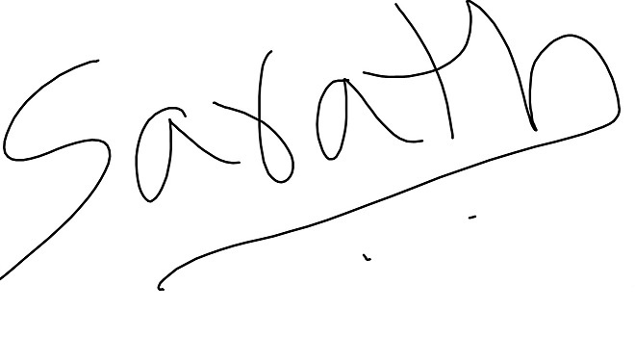

Name in Block Capitals: YELLAPU SARATH CHANDRA A R S

Date of Birth: 11/09/90(dd/mm/yy)

Date: 28/06/21

